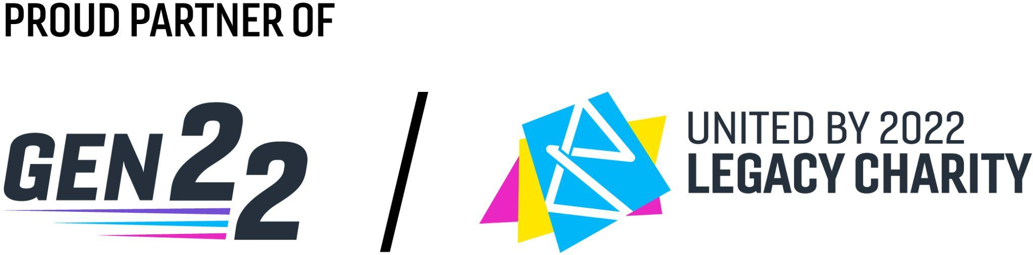

Solihull CEP
Solihull Cultural Education Partnership (CEP) is a network of arts and cultural professionals, education providers & creative advocates, who collaborate to create opportunities for children & young people (aged 0–25yrs) in Solihull to access the arts.
The work spans across the entire Solihull borough, from Castle Bromwich to Knowle, and Chelmsley Wood to Shirley. Solihull CEP’s vision is for all children and young people, schools, and youth organisations in Solihull to expect and engage in exciting and meaningful arts and cultural activity.

Gen 22: Young Artist Incubator
In partnership with United by 2022, Solihull CEP will be developing and delivering a series of one week workplace incubator projects which will see young people (16-24) working with artists and companies on intensive projects designed to mimic the pressures and opportunities of careers in the creative and cultural industries. There are five workplace incubators available:

Theatre - Led by Calico
11th - 15th June

TV - Led by Caroline Officer
29th July - 2nd August

Music - Led by Liz Birch
12th - 16th August

Visual Arts - Led by Art at The Heart
19th - 23rd August

Film - Led by Tiger Features
14th - 18th October

Person Specification
- Aged 16 - 24
- Lives, studies, or works in Solihull or the West Midlands
- Passion and interest in the arts and developing a career in the arts and cultural sector.
- Committed, reliable and organised.
- As part of this programme, we are keen to maximise engagement from a diverse range of backgrounds, including NEETS, young people at risk of offending and those from lower socio-economic groups.

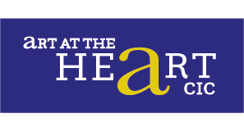
Visual Arts
Led by Art at The Heart
19th - 23rd August

Art at the Heart CIC's visual arts incubator is an opportunity to work with Art at the Heart's co-founders and resident artists Kamaljit Suman and Mukesh Kumar to co-produce a live project to develop a large public artwork. This will be an opportunity to network with a local visual arts organisation that has been operating in Solihull for 8 years. The incubator provides potential opportunities to:

- Identify self-development areas.
- Develop skills in working with clients to understand and clarify a brief,
- Develop imaginative and creative solutions suitable to the brief.
- Action plan and help to deliver a self-contained project, whilst developing self-identified skills needs.
- Investigate range and limitations of production methods.
- Understand health and safety regulations and considerations when working on site.
- Team working skills: appreciating and working with a diverse group of people in a respectful and productive way.
- Develop a creative and 'can do' mindset.
- Learn to accept critical feedback.
- Develop independent evaluation skills.
- Gain valuable work experience and real insights into the creative industries.
- Develop time management skills in time-sensitive contexts.
- Self-reflection and self-development skills

Week Outcome
Creation of a large public artwork / mural

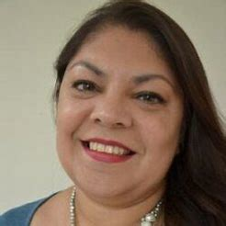
Who are Art at The Heart?

Meet Kamaljit Suman and Mukesh Kumar
www.artattheheartcic.org

Art at the Heart CIC is a visual and combined arts organisation that works in the community to combat inequality and support wellbeing through creative and cultural activities and education. We run two well-attended family festivals per year for 'Holi-The festival of Colour' and 'Diwali-The Festival of Light' in Solihull. We run Art Clubs for three age groups, including Youth, all year round and have been involved in numerous Arts and Health projects with Birmingham City Council. We have a specific interest in supporting young people from diverse backgrounds who are underrepresented in the arts especially in leadership positions.

We specialise in large collaborative artworks - our largest to date being two storeys high. We have collaborated with schools, community groups and workplaces at locations and for special events including the late Queen's platinum jubilee, Refugee Week, The Mayor's Community Weekend, Langley Primary School's 50th Anniversary. The greatest benefits of our work cited by our community include enjoyment, learning new skills, feeling part of a community, and developing confidence (and not just in art).

Theatre
Led by Calico Theatre
11th - 15th June

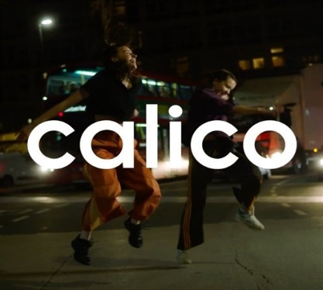
Participants will create and perform an original theatrical production. Participants will work with Calico's co-Directors Daz Scott and Martha Harrison to devise a piece of multimedia theatre, which will blend theatre with mediums like movement, verbatim voice recording, and video projection. Participants will not need to be experienced in any of these mediums but will need to be open to collaboration and ready to experiment with new styles and ideas in the rehearsal room.
Throughout the week, participants will gain an insight into Calico's creative process, as well as industry-standard practice. They will take on roles of theatre-makers and performers, workshopping, rehearsing, and then performing a brand-new piece, at The Core. The Incubator will provide participants with the opportunity to gain experience of working in the theatre industry, including gaining skills in devising, collaboration, producing, and performing, as well as opportunities for mentoring and support on their individual creative journey.

Week Outcome:
Creation of an original theatre piece, performed to an audience at The Core Theatre Saturday 15th June.

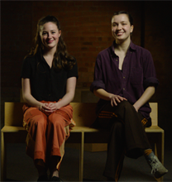
Who are Calico?
Meet Daz Scott and Martha Harrison
www.calicotheatre.co.uk

We are Calico: a Birmingham-based arts and activism company, co-creating artistic campaigns with local young people. We use art; live performance, short films, virtual reality experiences, to platform the voices of young people on issues that matter to them.
In the past, we have performed on seafronts, in car parks, and even on trains, and we've built creative campaigns which have raised awareness, shifted perspectives, and even contributed to changing laws. We have been funded by Arts Council England, Innovate UK, Birmingham City Council, and the West Midlands Combined Authority, and have worked with organisations like Camden People's Theatre, Worthing Theatres and Museum, United by 2022, the University of Birmingham.

Film
Led by Tiger Features
14th - 18th October

Over one week you will learn the entire film making process from initial concept to producing a fully edited film. The practical workshop will teach you the differences between filming dramas verses documentaries, production planning and story boarding camera techniques and angles, working with a crew, visual storytelling, lighting, audio, and film editing using Final Cut Pro X. At the end of the week the group will have a sharing event where we will watch our films and celebrate what we have produced together!

Week Outcome:
Original film showcased in Cineworld Solihull, as part of The Core Theatres Short is Beautiful Festival, 22nd & 23rd October.

Who are Tiger Features?

Meet Nicola Prestage
www.tigerfeatures.com

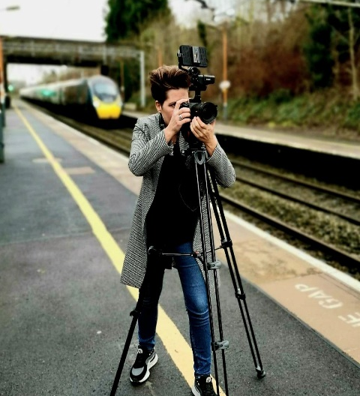
Nicola is a local documentary filmmaker, film facilitator and digital artist. My film career started over a decade ago filming and producing adverts and customer insight films for clients such as River Island, John Lewis, Jaguar, and eBay.
Her digital artwork has been displayed at various galleries throughout the UK including Birmingham Museum and Art gallery and alongside Grayson Perry’s artwork at The National Trust, Croome Court. Her most recent short drama Which Side of the Tracks, a County Lines themed film has been nominated for a Royal Television Society 2023 award. She produces creative and engaging films which help people understand the challenges that other people face and to dispel negative stereotypes. She also facilitates film and digital art projects working with the following communities- Mental Health, LGBTQI+, Looked After Children, Recovering Drug and Alcohol Addiction, Ex- Offenders, PRU’s, Secure Units & Hospital Schools. She is passionate about facilitating and enjoys working with people to support them in unleashing their film making potential.

Television
Led by Caroline Officer
29th July - 2nd August

This incubator focuses on how to get into the TV industry, rather than on the creation of a specific product or outcome.

The course will include:
- An introduction to screen production: genres, roles, and team structures
- The production landscape in the West Midlands and beyond
- Focus on entry-level roles - the runner/assistant role.
- The employability toolkit in five steps
- The freelancer survival guide – how to find work, negotiation techniques, rate cards, tax and national insurance, invoicing.
- Guest speakers
- Health & Safety in production – risk assessments
- Practical workshop(s) – How to become a critical viewer to understand how programmes are made.

Who is Caroline Officer?
29th July - 2nd August
Caroline is an award-winning television producer and teacher. She established her career at the BBC in Birmingham before moving to London to series produce the original Ready, Steady Cook. Caroline also developed and produced the popular daytime cookery show, Can’t Cook, Won’t Cook with presenter Ainsley Harriott, winning the National Television Award for Best Daytime Show.
In addition to her television work, she was appointed Head of Live Events at Endemol and adapted both Ready, Steady Cook and Changing Rooms into successful live formats. She was also the showrunner for the BBC Good Food Show Celebrity Theatre for 7 years.
Caroline moved back to Birmingham to establish the Endemol Midlands production office and over seven years produced 3,000 hours of television and provided employment for many television freelancers in the region.
has worked closely with Screen Skills to design and deliver an Employability Toolkit for graduates and managed the local Trainee Finder Bootcamps. She also works regularly with Film London delivering training. In 2022, she worked closely with leading sports producers, Sunset + Vine, to deliver a training programme for 150 local people to work in production roles on the Birmingham Commonwealth Games. Caroline is currently working with Solihull College and University Centre designing and delivering Screen Production Bootcamps. She is passionate about broadening access and opportunities for aspiring and established screen professionals.

Music
Led by Elizabeth J Birch
12th - 16th August

The music incubator will focus on honing the participants as a DIY artist by writing, recording, and preparing to release a single; they will learn how to write a song, record, and produce their song, and mix their song ready for mastering. They will also learn how to assemble promotional materials for (and how to distribute) their singles release (such as artwork, distribution, PRS, etc), as well as prepare for a performance of their track at the end of the week.

Week Outcome:
Performance of original music on Friday 16th August at The Core Theatre
A fully mixed and mastered track to take away ready for release.

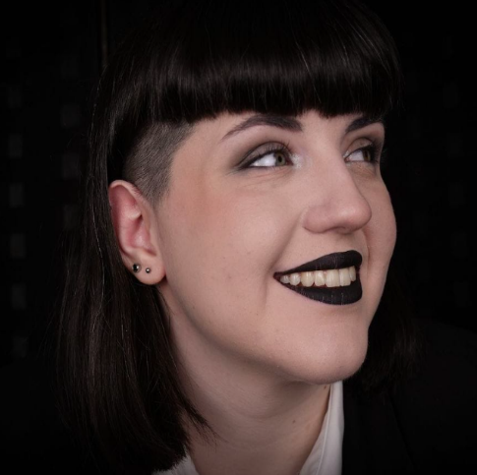
Who is Elizabeth J Birch?

Elizabeth J. Birch is an undefined glitch, known for blurring the boundaries and striving for innovative ways to envision and make music. An award-winning musician, she combines synthesisers, haunting vocals, and ordinary everyday objects to craft a sonic landscape that tells stories and portrays emotion. A producer, composer, vocalist, and tech-enthusiast, her second EP ‘Kenopsia’ released in 2023 explored challenging subjects such as loss and grief, and received radio support from BBC Introducing, Unmade Radio and Black Country Radio. She won the ‘Inspirational Music Leader’ award from Youth Musician 2023 for her inclusive community music and facilitation workshops, focused on song writing, technology and youth voice.

